**Insert School Logo**

**Semester Two**

**Examination 2021**

**Question/Answer booklet**

**MATHEMATICS**

**METHODS UNIT 3 and 4**

**Section One:**

**Calculator–free**

|  |
| --- |
| Student Name: _____________________________________ |
| Teacher’s Name: _____________________________________ |
|  |

**Time allowed for this section**

Reading time before commencing work: five minutes

Working time for paper: fifty minutes

**Material required/recommended for this section**

**To be provided by the supervisor**

This Question/Answer booklet

Formula Sheet

**To be provided by the candidate**

Standard items: pens (blue/black preferred), pencils (including coloured), sharpener, correction tape/fluid, erasers, ruler, highlighters

Special Items: nil

**Important note to candidates**

No other items may be taken into the examination room. It is **your** responsibility to ensure that you do not have any unauthorised notes or other items of a non–personal nature in the examination room. If you have any unauthorised material with you, hand it to the supervisor **before** reading any further.

**Structure of this paper**

|  |  |  |  |  |  |
| --- | --- | --- | --- | --- | --- |
|  | Number of questions available | Number of questions to be attempted | Working time (minutes) | Marks available | Percentage of exam |
| **Section One**  **Calculator—free** | **10** | **10** | **50** | **50** | **35** |
| Section Two  Calculator—assumed | 12 | 12 | 100 | 100 | 65 |
|  | | | | 150 | 100 |

**Instructions to candidates**

1. The rules for the conduct of Western Australian external examinations are detailed in the

*Year 12 Information Handbook 2021.* Sitting this examination implies that you agree to abide by these rules.

1. Answer the questions according to the following instructions.

**Show all your working clearly.** Your working should be in sufficient detail to allow your

answers to be checked readily and for marks to be awarded for reasoning. Incorrect answers given without supporting reasoning cannot be allocated any marks. For any question or part question worth more than two marks, valid working or justification is required to receive full marks. If you repeat an answer to any question, ensure that you cancel the answer you do not wish to have marked.

It is recommended that you **do not use pencil**, except in diagrams.

1. You must be careful to confine your responses to the specific questions asked and to follow any instructions that are specific to a particular question.
2. Spare pages are included at the end of this booklet. They can be used for planning your responses and/or as additional space if required to continue an answer.

* Planning: If you use the spare pages for planning, indicate this clearly at the top of the page.
* Continuing an answer: If you need to use the space to continue an answer, indicate in the original answer space where the answer is continued, i.e. give the page number. Fill in the number of the question that you are continuing to answer at the top of the page.

1. The Formula Sheet is **not** handed in with your Question/Answer Booklet.

# Section One: Calculator–free 35% (50 marks)

This section has **ten (10)** questions. Attempt **all** questions. Write your answers in the spaces provided.

Spare pages are included at the end of this booklet. They can be used for planning your responses and/or as additional space if required to continue an answer.

* Planning: If you use the spare pages for planning, indicate this clearly at the top of the page.
* Continuing an answer: If you need to use the space to continue an answer, indicate in the original answer space where the answer is continued, i.e. give the page number. Fill in the number of the question(s) that you are continuing to answer at the top of the page.

Working time: 50 minutes

**Question 1 (5 marks)**

(a)The function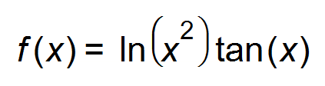is defined over a certain domain.

Find the equation of the tangent at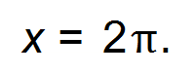 (3 marks)

(b) Evaluate 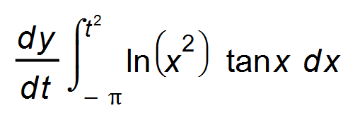. (2 marks)

**Question 2 (8 marks)**

The probability distribution of a random variable *Y* is such that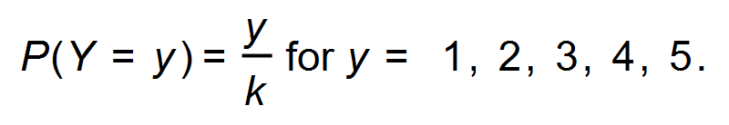

(a) Find the value of *k.* (1 mark)

(b) Determine the probability that *Y* is at least 3. (1 mark)

(c) Find the expected value of *Y*. (1 mark)

(d) The random variable *Y* is transformed into another random variable, *X*, such that

0.1*Y* = *X $-$* 2.

(i) Find the expected value and the standard deviation of the random variable *X*.

(3 marks)

(ii) Determine the probability: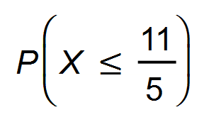. (2 marks)

**Question 3 (5 marks)**

The graph of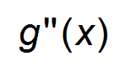 is shown below. passes through the points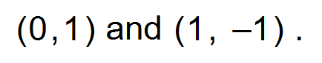

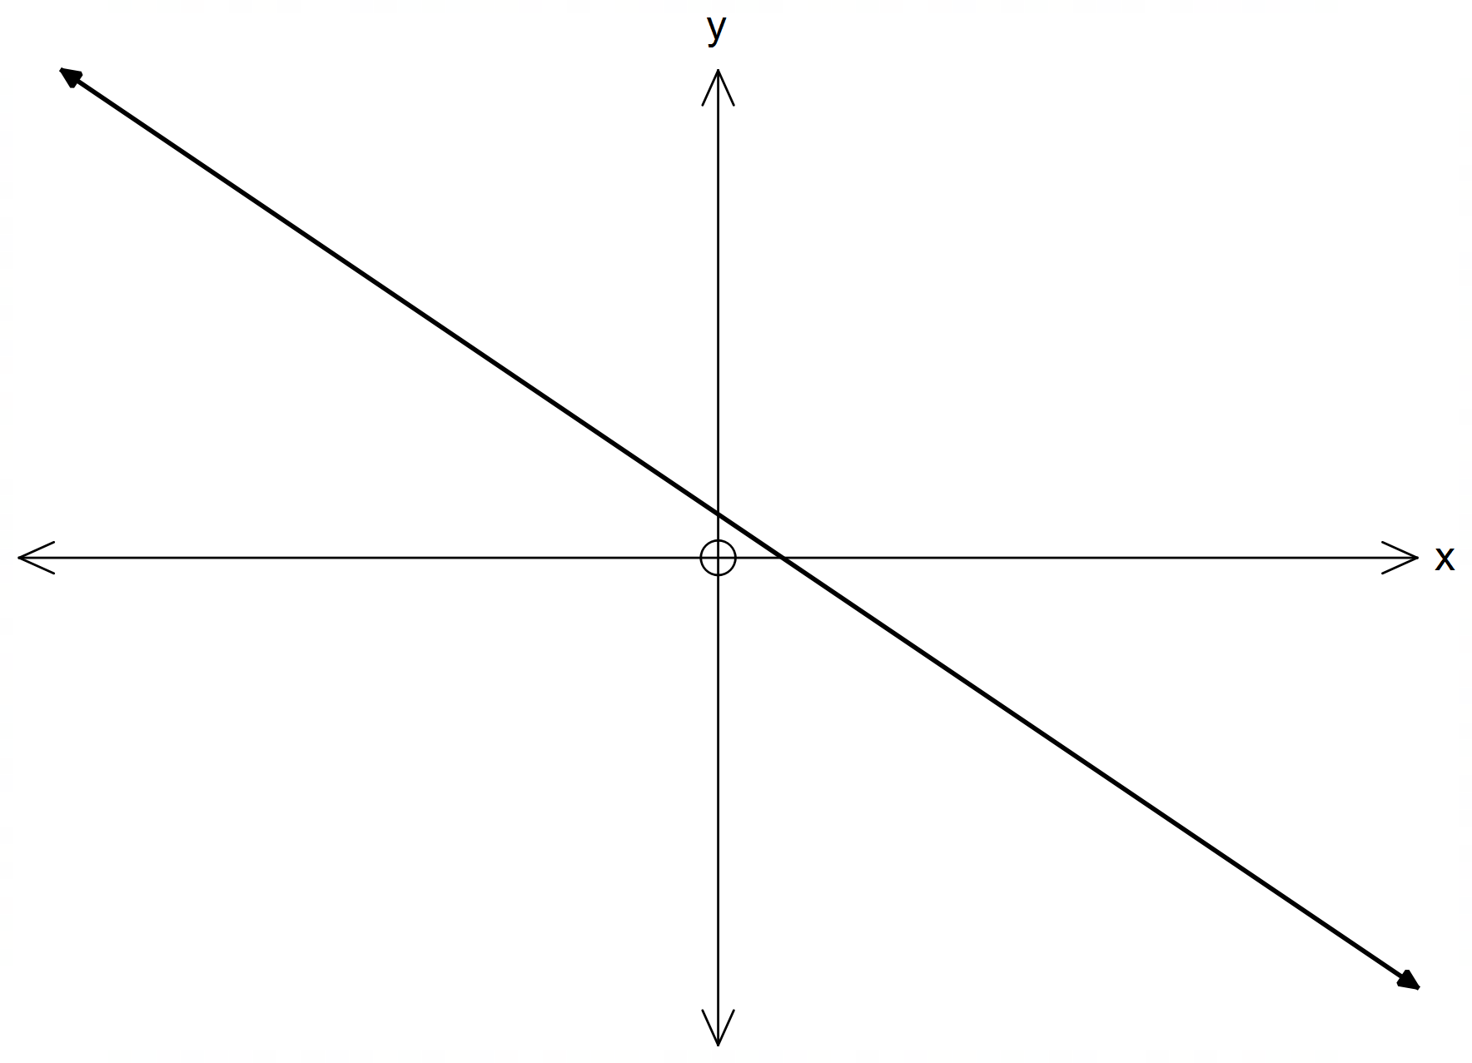

(a) For which values of *x* is the function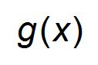concave down? (2 marks)

(b) State the nature of the turning point of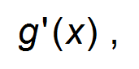the gradient function of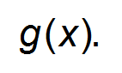 (1 mark)

(c) On the same set of axes, draw the graph of the function (2 marks)

**Question 4 (7 marks)**

(a) Consider the graphs of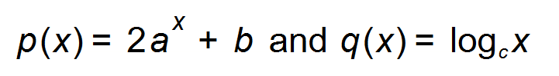shown below.

The asymptote of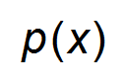and the graph of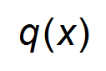pass through the point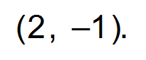

The graphs intersect at C.

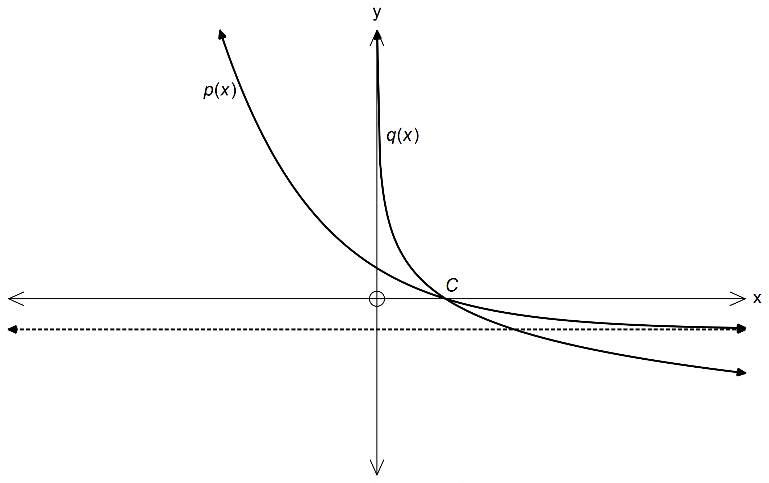

Find the values of *a*, *b* and *c.* (3 marks)

(b) Find the value of 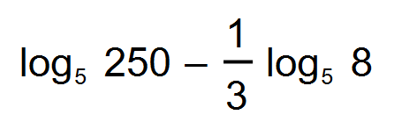. (2 marks)

(c) Solve for *x*, 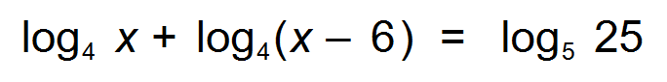 (2 marks)

**Question 5 (4 marks)**

Let *X* be a normally distributed random variable with a mean of 72 and a standard deviation of 8. Let *Z* be the standard normal random variable.

Use the result that *P*(*Z* < 1) = 0.84, correct to two decimal places, to find:

(a)the probability that *X* is greater than 80. (1 mark)

(b) the probability that 64 < *X* < 72. (1 mark)

(c)the probability that *X* < 64 given that *X* < 72. (2 marks)

**Question 6 (3 marks)**

Two variables, *x* and *y*, are connected by the equation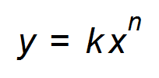.

The graph of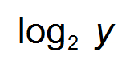against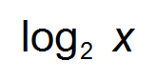is a straight line as shown below.

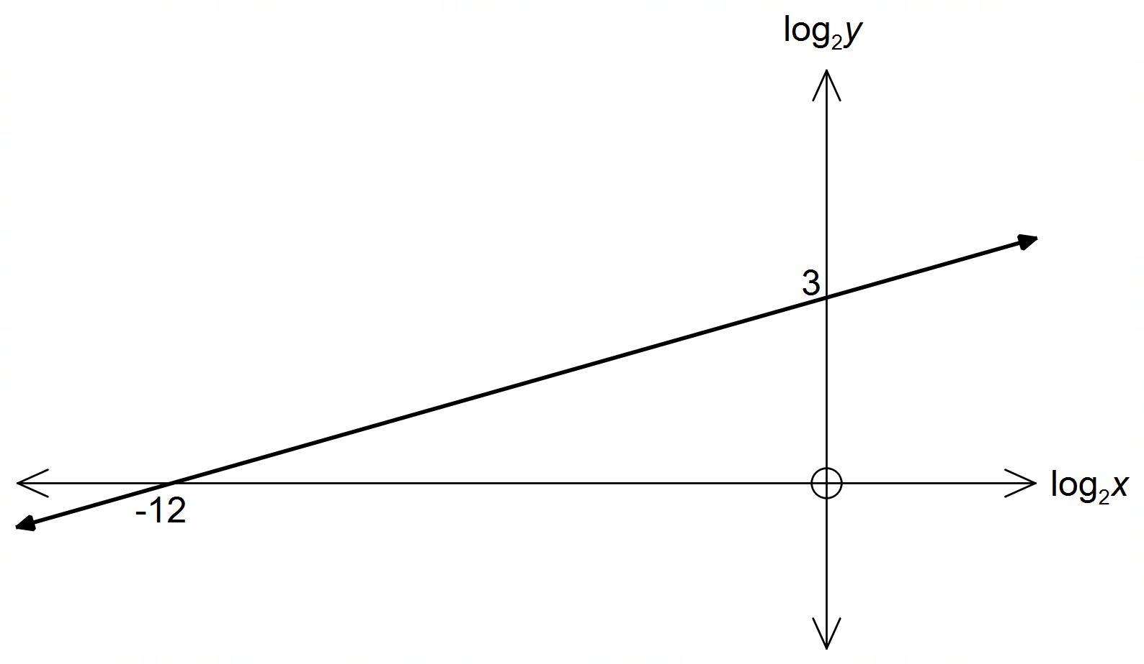

Find the values of *k* and *n*. (3 marks)

**Question 7 (4 marks)**

On a suitable domain, a function is defined by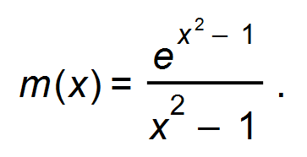

Find the exact co−ordinates of the stationary points of the function. (4 marks)

**Question 8 (4 marks)**

Trains leave Fremantle station every 20 minutes. Lauren has no timetable and so every waiting time from 0 to 20 minutes is equally likely.

(a) State the probability density function for the time she has to wait. (1 mark)

(b) Determine the probability that she will have to wait less than 5 minutes for the next train, given she has to wait more than 3 minutes. (2 marks)

(c) State the median of the distribution. (1 mark)

**Question 9 (3 marks)**

The shaded region shown is enclosed by the functions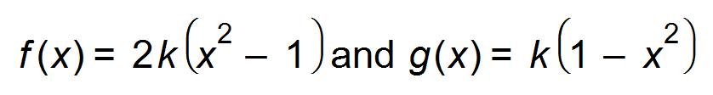, where *k* > 0, as shown below.

Given that the area of the shaded region is 8, find the value of *k*.

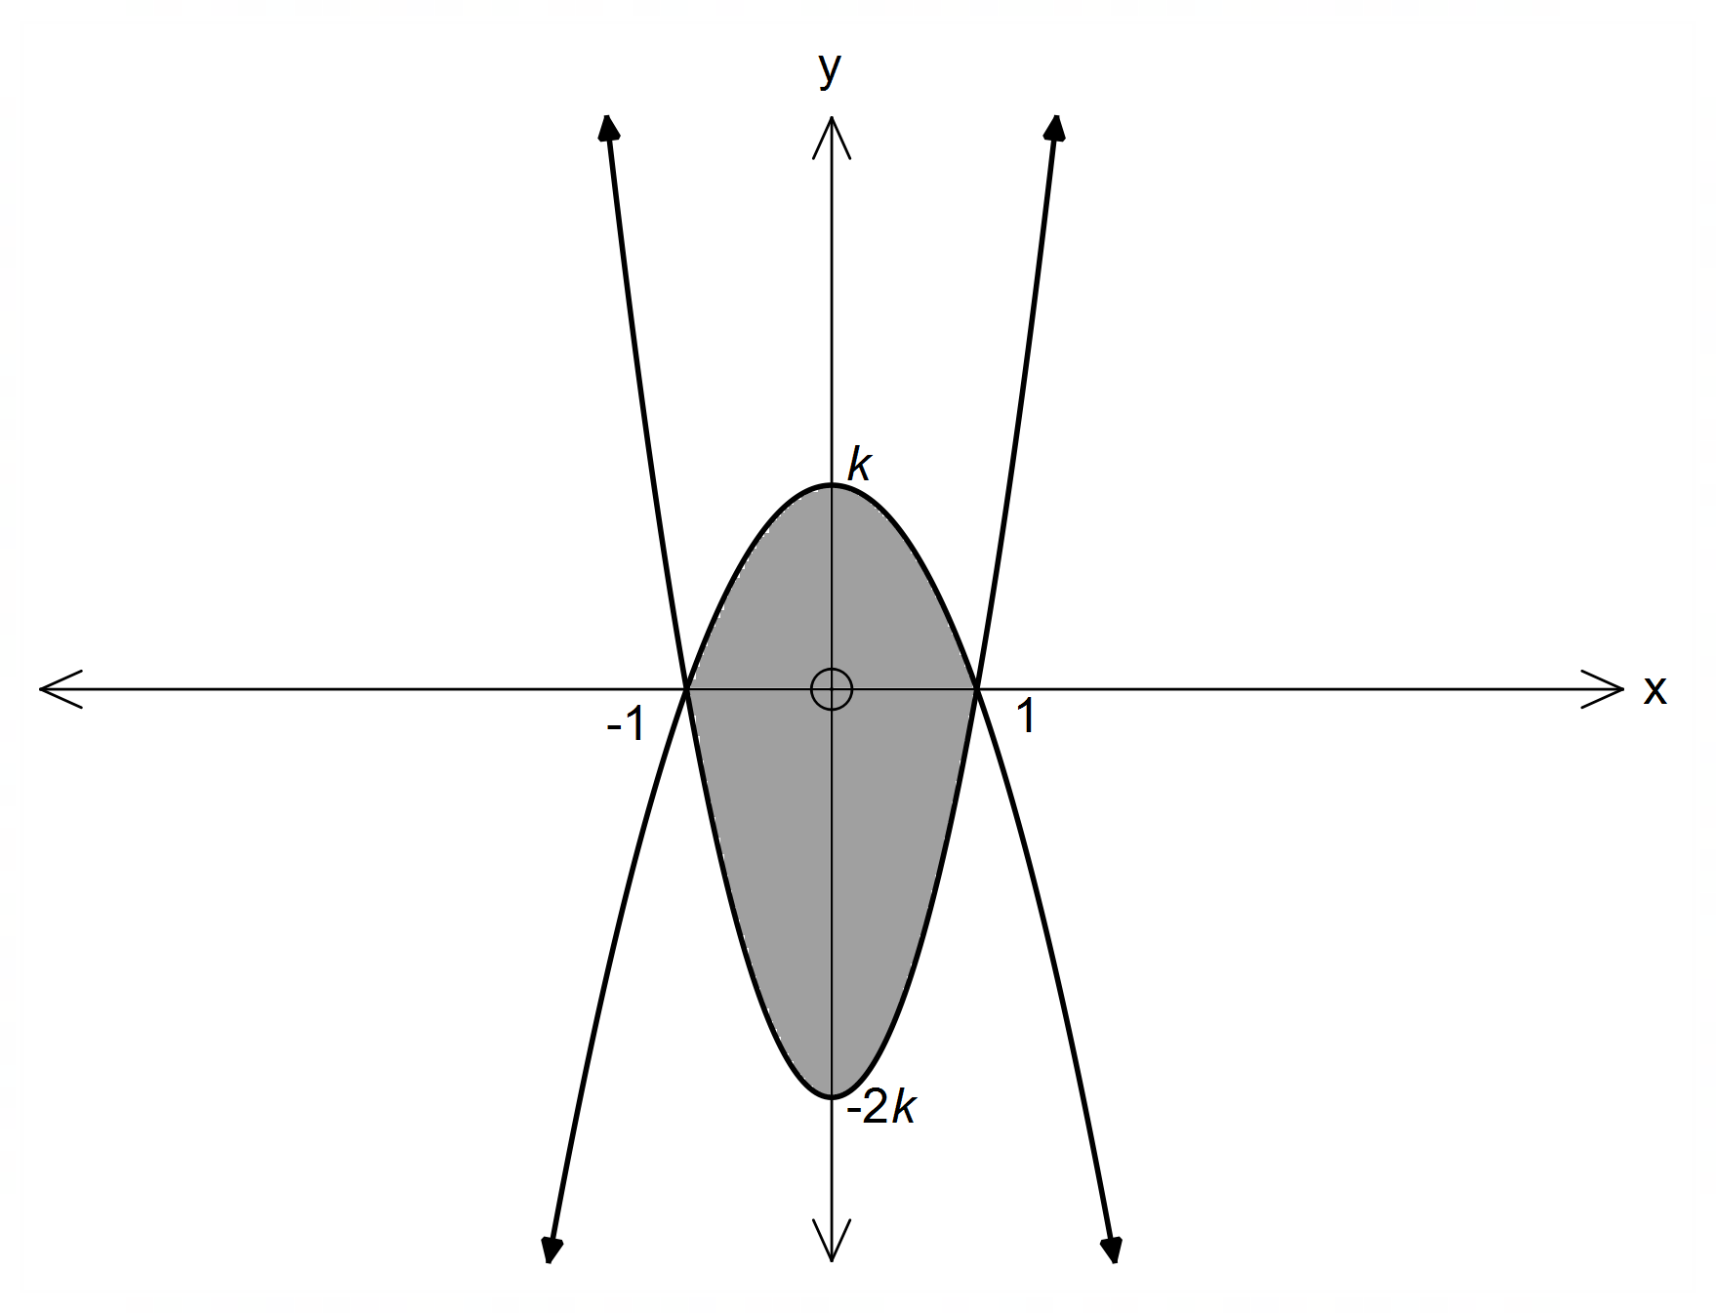

**Question 10 (7 marks)**

The graph of ${f\left(x\right)= log}_{\frac{4}{3}}{ x}$ is shown below. 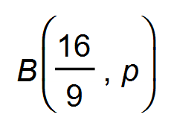is a point on $f(x)$.

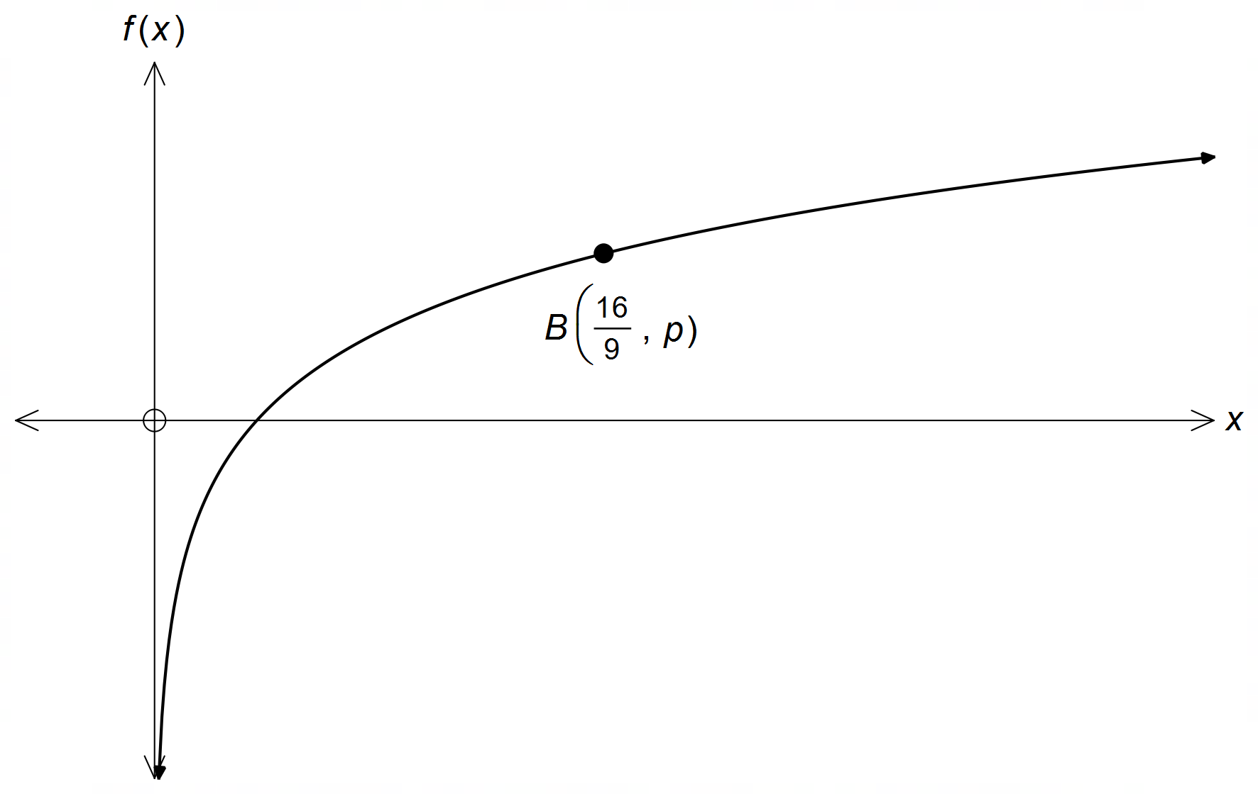

(a) For which value(s) of *x* is $\log_{\frac{4}{3}}{ x} ≤0$? (2 marks)

(b) Determine the value of *p.* (2 marks)

(c) (i) Sketch the graph of the derivative of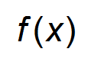on the same axes. (1 mark)

(ii) State the equation of the derivative graph. (2 marks)

**End of Questions**

**Additional working space**

Question number(s): ……………………